INVOLVED IN YACHT RACING?
INTERESTED IN THE RACING RULES?

maybe in coaching, training competitors or officials
or in protests as a party or judge.

The ability to set out scenarios clearly and progressively is often the difference between success and failure – whether in the classroom or the protest room. Two invaluable aids to doing this are now available and are being used at many major events – e.g. America’s Cup 2003, the Volvo Ocean Race and many international and national championships.

- The magnetic boat kit: perfect for setting out scenarios on a table or on a magnetic board for greater visibility. Kit contains: 4 boats, numbered 1 – 4 in each of red, green, blue and yellow; committee, mark, gate, guard, jury, umpire and wing judge boats; wind, tide and current indicators; and course, gate, start, finish and alternative marks. All precision cut in magnetic material with the boats equipped with independently moveable booms for clear indication of tack.

- TSS - Tactical Sailing Solutions: the computer drawing kit for brilliant scenario production, as used for the Louis Vuitton Cup and America’s Cup 2000 and 2003
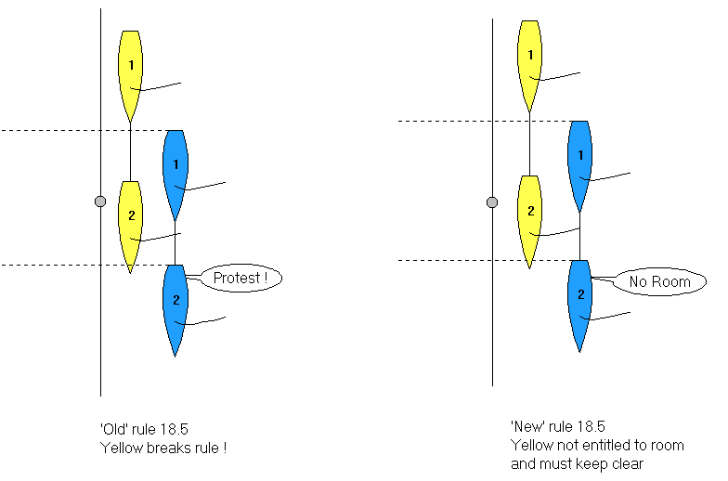

Available on CD including many of the scenarios from Auckland 1999-2000.
Each priced at £40, or £75 for both, post paid from:

CHRIS SIMON

ISAF International Umpire, Judge and Race Officer
RYA National Judge, Umpire and Race Officer

13 Malt House Close Tel/Fax + 44 (0)1753 862194
Old Windsor Mobile: + 44 (0)7970 904970
Berkshire SL4 2SD ChriSimon@compuserve.com

